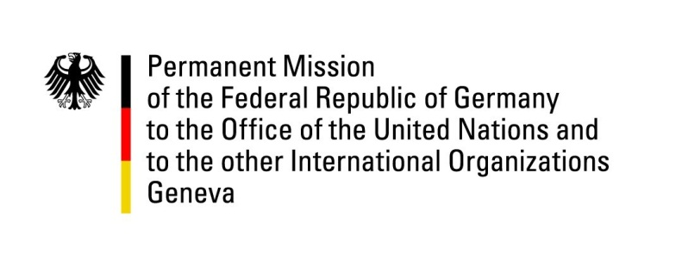

United Nations Human Rights Council
24rd Session of the UPR Working Group
Geneva, 25 January 2016

---
Questions and Recommendations to Solomon Islands

German National Statement

Thank you, Mr President,

Germany welcomes the delegation of Solomon Islands to the UPR.

Germany notes with satisfaction the positive development of Solomon Islands in the fields of social cohesion, governance and human trafficking and encourages its Government to take further steps to strengthen the national human rights situation. Germany also welcomes the passing of the Family Protection Act in 2014, which criminalizes domestic violence.

Mr President,

Germany wishes to offer the following recommendations to Solomon Islands:

- Ensure that the rights of children are protected by codifying the provisions of the Convention of the Rights of the Child in the national legislation and ratifying the Optional Protocol to the Convention on the Rights of the Child on the Involvement of Children in Armed Conflict and the Optional Protocol to the CRC on the Sale of Children, Child Prostitution and Child Pornography.
- Continue with its efforts to develop a national policy for the benefit of persons with disabilities, including the ratification of the Convention on the Rights of Persons with Disabilities.

Thank you, Mr President.

